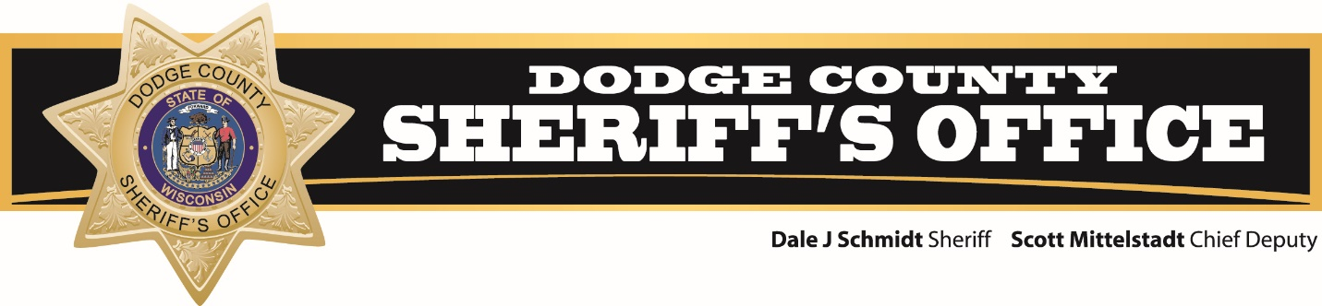

**Date: December 26, 2022**

**For more information contact:**

**Sergeant Jermey Wolfe (**[**jwolfe@co.dodge.wi.us**](mailto:jwolfe@co.dodge.wi.us)**)**

**Dodge County Sheriff’s Office participating in Drive Sober or Get Pulled Over holiday campaign**

This holiday season, the Dodge County Sheriff’s Office is joining law enforcement agencies across Wisconsin and the nation to prevent tragedies in our communities.

There will be more officers out patrolling to get impaired drivers off the roads during the annual Drive Sober or Get Pulled Over holiday enforcement campaign. It runs Friday, December 16 through Sunday, January 1, New Year’s Day.

The campaign is not simply about stopping or arresting drivers. It is focused on saving lives. Someone is killed or injured in an impaired driving crash every two hours in Wisconsin. During the last holiday season, there were nearly 400 crashes that involved an impaired driver; these crashes killed seven people and injured 192 others. In 2020, over 11,000 people died in alcohol impaired driving traffic deaths (NHTSA).

“We cannot do this alone. We ask everyone to protect themselves and their neighbors by always driving sober,”Sergeant Jermey Wolfe said. “If a friend is about to drink and drive, take the keys and help them get home safely. If you see a driver you suspect is under the influence, call 911.”

Alcohol and drugs can have a significant impact on a driver’s focus and ability to maintain control behind the wheel. Last year in Wisconsin, there were 6,368 alcohol-related crashes that killed 166 people. Alcohol contributed to more than a quarter of all traffic fatalities.

Wisconsin officers have special training to help combat impaired driving, including:

* 6,382 police officers trained in Advanced Roadside Impaired Driving Enforcement to help detect and remove impaired drivers from the roads.
* 365 highly trained Drug Recognition Experts, among the most in the nation.
* [25 multi-jurisdictional high-visibility OWI task forces](https://wisconsindot.gov/Documents/safety/enforcement/agencies/WisconsinOWITaskForces2022.pdf) operating around the state.

Everyone in the community can help with this effort in several ways:

* If you plan to celebrate, identify a sober designated driver, or find a safe ride home. Never allow someone who is impaired to get behind the wheel.
* If you suspect a driver is impaired call 911. Provide as much detail as possible on the driver, vehicle, and location.
* Download the free Drive Sober mobile app from the [WisDOT website](https://zeroinwisconsin.gov/programs/impaired-driving/). The app includes a find a ride feature to help locate mass transit and taxi or rideshare services.
* Some bars and restaurants have programs to provide patrons a [safe ride home](https://tlw.org/saferide/).
* Buckle up and put your phone down. Every trip, every time.

“The holidays are a special time of year for many. We want everyone to enjoy the season, but we need commitment from drivers. This enforcement campaign helps us get the message out that drunk driving is illegal and it takes lives. Help us put an end to these needless tragedies,” Sergeant Jermey Wolfe said.

