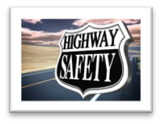

Dodge County Traffic Safety Commission

124 West St. Juneau, WI 53039

Joel Kiesow, Coordinator

Captain Chad Enright, Assistant Coordinator

PRESS RELEASE : Children, Vehicles and Heatstroke

The Dodge County Traffic Safety Commission reminds motorist and the general public to be aware of children left alone in vehicles during the hot summer months.

Coordinator Joel Kiesow states that heatstroke is one of the leading causes of death among children.

Sadly, these are the current statistics:  
- Child vehicular heatstroke fatalities in 2018 = 51  
- Child vehicular heatstroke fatalities in 2017 = 43

Heatstroke is the leading cause of vehicular non-crash-related deaths for children under 14. In fact, each year, an average of 38 children have died from heatstroke since 1998.

**Yet, this tragedy is 100% preventable**

Keep in mind a child’s sensitivity to heat; children overheat up to five times faster than adults.

• In 10 minutes, a car’s temperature can rise over 20 degrees.

•Even at an outside temperature of 60 degrees, the temperature inside your car can reach 110 degrees within minutes.

•A child dies when his/her body temperature reaches 107 degrees.

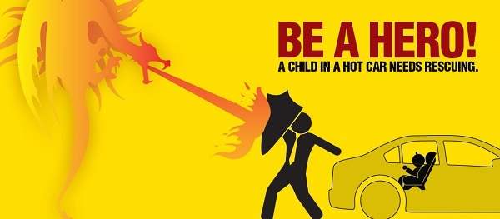

Take action if you see a child alone in a car. It’s never okay to leave a child alone in a car, even for a few minutes, and even if the car is on in an unattended vehicle. TAKE ACTION if You Notice a Child Alone in a Car! Here’s What You Can Do

• **Don’t wait more than a few minutes for the driver to return.**

•If the child is not responsive or is in distress, immediately:

◦Call 911.

◦Get the child out of the car.

◦Spray the child with cool water

•If the child is responsive in the car:

◦Stay with the child until help arrives.

◦Have someone else search for the driver or ask the facility to page them.

Understand the Potential Consequences of Kids in Hot Cars

•Severe injury or death

•Being arrested and jailed

•A lifetime of regret

Protecting children is everyone’s business—know what to do if you see a child alone in a car.